MES Traceability Solution




Microtek International Pvt. Limited

Software Requirement Specification (SRS)

Project ID:
The document details the summary of solution architecture and approach for the development of MES Traceability Solution for Microtek International Pvt. Ltd. The document is based on the inputs, system study, discussions and meeting held between BCI & Microtek International Pvt. Ltd. Teams.
Prepared By: Prateeksha, Leena
Submission Date:
Version: 1.0
BAR CODE INDIA, 691 Udyog Vihar Phase V, Gurugram, Haryana-122016, PH: 0124 4337555

Masters

Trolley Master
The module will be used to save Trolley details in the database. User can add, edit, and delete the Trolley details.
Data Fields | - Trolley ID  - Description  - Capacity  - Is Active Status i.e. Yes/ No
Process Steps | - Enter Trolley ID.  - Enter Description of the Trolley.  - Enter Capacity of the Trolley.  - Select Active Status as Yes/ No.  - Save the Trolley details in database.
Functions | Add, edit/update, and delete Trolley details as per requirement.

Identification Operations

Trolley Identification
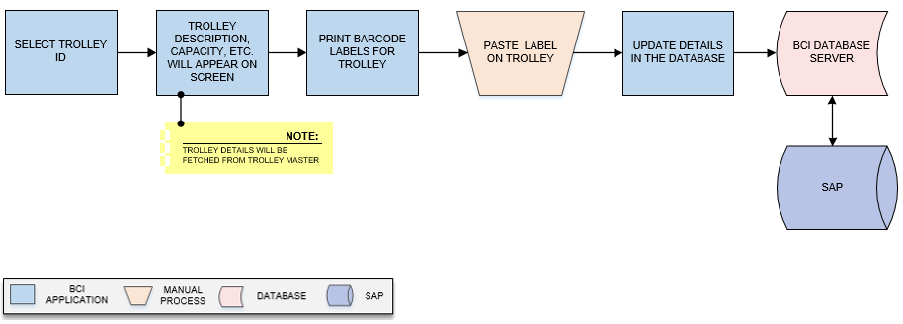
Activities
Module Description | This module will be used to provide unique identification to the each Trolley by printing barcode labels for them and save the details in the database  *This activity will be done using Web Application.

Pre-Conditions | - Trolley master should be available.  - Trolley details should be maintained.

Process Steps | - Select Trolley ID from dropdown list.  - Corresponding Trolley details such as Description, Capacity, etc. will appear on screen.  *Trolley details will be fetched from Trolley Master.  - Print barcode labels against selected Trolley.  - Paste label on Trolley.  - Update details in database.

Post-Conditions | - Printing details will get saved in the database.

Validations | - An alert should be displayed in case Trolley IDs are not available in list.  - An alert should be displayed in case invalid Trolley data is entered/selected.  - An alert should be displayed in case Trolley Barcode label is not printed.

Inventory Replenishment (Bin – Component Mapping)
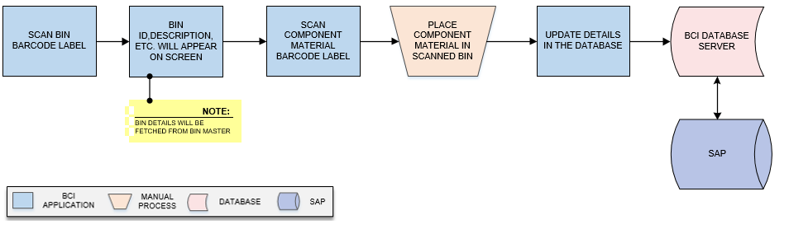
Activities
Module Description | This module will help user to map RM Components with the Bin and updating details in the database.  *This activity will be done using Device Application.

Pre-Conditions | - Bin master should be available.  - Material and Component details should be available.

Process Steps | - Scan Bin Barcode Label.  - Bin details such as Bin ID, Active status, Description, etc. will appear on screen.  *Bin details will be fetched from Bin Master.  - Scan Component Material barcode label.  - Place Component material in scanned Bin.  - Update Bin – Component mapping details in the database.

Post-Conditions | - Mapping details will get updated in database.

Validations | - An alert should be displayed in case duplicate/ invalid barcode label is scanned.  - An alert should be displayed in case of invalid activity.

Stencil Inventory
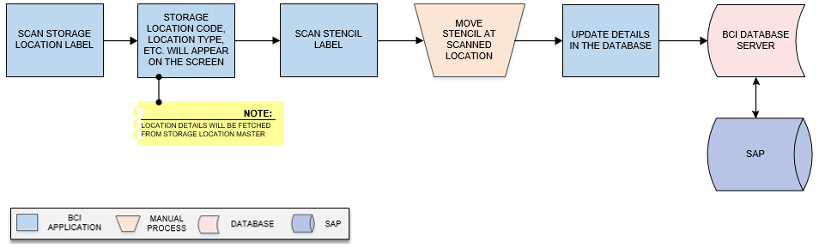
Activities
Module Description | This module will be used to maintain the Stencil Inventory details in order to keep track of stencils used for Solder Paste Printing Process. In this module Stencil is mapped with a storage location and Stencil Inventory will be saved in the database.  *This activity will be done using Device Application.

Pre-Conditions | - Storage Location master should be available.  - Location should have barcode label.  - Stencil should have barcode label.

Process Steps | - Scan Storage Location label.  - Location details such as Storage Location Code, Location Type, etc. will appear on the screen.  *Location details will be fetched from Storage Location Master.  - Scan Stencil label.  - Move stencil at scanned location.  - Update Stencil – Location mapping detail in the database.

Post-Conditions | - Stencil mapping location will get updated in database.  - Stencil- Location mapping will help in Inventory Count and maintaining record of Stencil for issuance.

Validations | - An alert should be displayed in case duplicate Location data is updated.  - An alert should be displayed in case Stencil label is not scanned.  - An alert should be displayed in case of invalid activity.

Rework
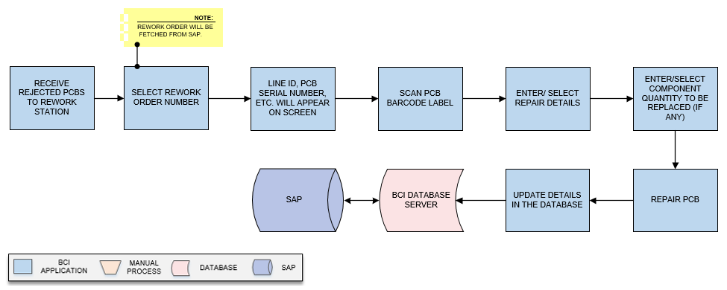
Activities
Module Description | This module will help user to repair the PCBs rejected from Production Line against Rework Order fetched from SAP and update corresponding rework details will get updated in the database.  *This activity will be done using Device Application.

Pre-Conditions | - Rework Order should be fetched from SAP.  - Interface will be required to fetch Rework Order from SAP.  - Line Master should be available.

Process Steps | - Receive Rejected PCBs to rework station.  - Select Rework Order Number.  *Rework Order will be fetched from SAP.  - Corresponding details such as Line ID, PCB Serial Number, etc. will appear on screen.  - Scan PCB Barcode Label against selected Rework Order.  - Enter/Select repair details.  - Enter/Select Component Quantity to be replaced (if any).  - Repair PCB.  - Update details in database.

Post-Conditions | - Rework details will get saved in the database.  - PCB will get repaired and sent back to Stage/ Line from which it was rejected.

Validations | - An alert should be displayed in case duplicate/ invalid barcode label is scanned.  - An alert should be displayed in case of invalid activity.  - Alert should be displayed if Rework Order Number is not available in list.  - An alert should be displayed in case Rework Order details are not fetched.
Data Required from Microtek | - Interface will be required to fetch Rework Order details from SAP and same will be provided by Microtek.

Chassis Label Printing
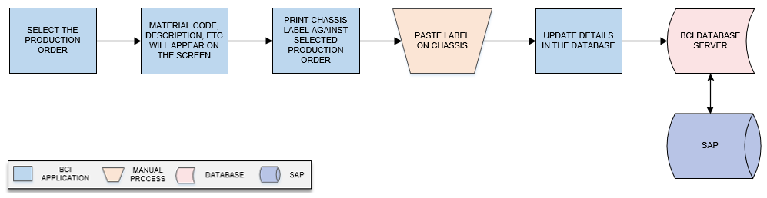
Activities
Module Description | This module will allow user to provide unique identification to each Chassis by printing barcode labels for them and save the details in the database  *This activity will be done using Web Application.

Pre-Conditions | - Production Order details should be fetched from SAP.  - Interface will be required to fetch Production Order details from SAP.

Process Steps | - Select the Production Order.  - Order details such as Material Code, Description, and Quantity will appear on the screen.  - Print Chassis Label against selected Production Order.  - Paste Label on Chassis.  - Update details in the database.

Post-Conditions | - Printing details will get saved in the database.

Validations | - An alert should be displayed in case Production Order Number is not available in list.  - An alert should be displayed in case Chassis Label is not printed.

Stock Take

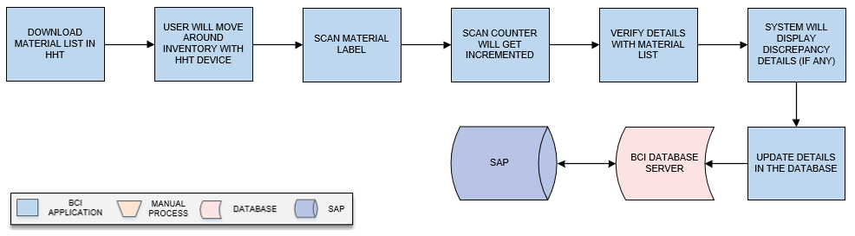

Activities
Module Description | The module will help user in physical audit of Material across multiple locations and provide information of number of Material transferred, misplaced, or available within the premises.  *This activity will be done using Device Application.

Pre-Conditions | - Material Master should be available.  - Material details should be maintained in Material Master.  - Inventory details should be updated after each transaction.  - HHT device should be available.  - Audit record should be maintained.

Process Steps | - Download Material list in HHT.  - User will move around inventory with HHT device.  - Scan Material Label.  - Scan Counter will get incremented with each valid label scanning.  - Verify details with Material list.  - System will display discrepancy details on process completion, if any.  - Save details in the database.

Post-Conditions | - Audit details will get saved in the database.

Validations | - An alert message is displayed in case of any error / invalid activity.  - System will validate Material barcode and display error in case of invalid or duplicate barcode is scanned.

Cycle Count
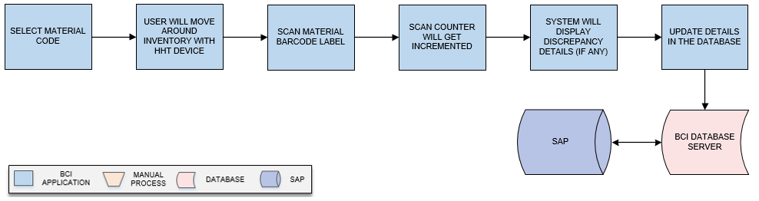
Activities
Module Description | The module will help user to count and verify the inventory of specific Material such as Line Material within the premises  *This activity will be done using Device Application.

Pre-Conditions | - HHT device should be available.

Process Steps | - Select Material Code.  - User will move around inventory with HHT device.  - Scan Material Barcode Label.  - Scan counter incremented with each valid label scanning.  - System will display discrepancy details on process completion, if any.  - Save details in the database.

Post-Conditions | - Audit details will get updated in database.

Validations | - An alert message is displayed in case of any error / invalid activity.  - System will validate Material barcode and display error in case of invalid or duplicate barcode is scanned.

